KJV Genesis & Exodus Per____ Name________________________________________________________
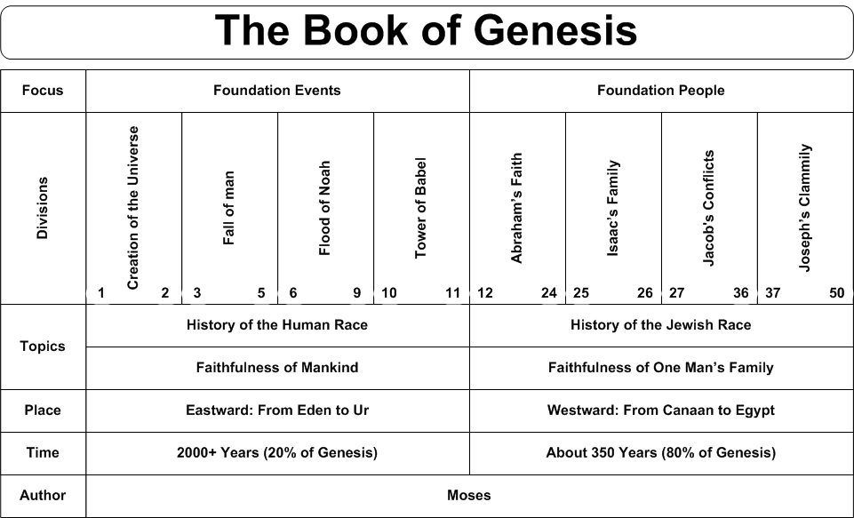
Source: http://www.swartzentrover.com/cotor/Bible/Bible/Bible%20Charts/Genesis.htm

KJV Genesis & Exodus Per____ Name________________________________________________________
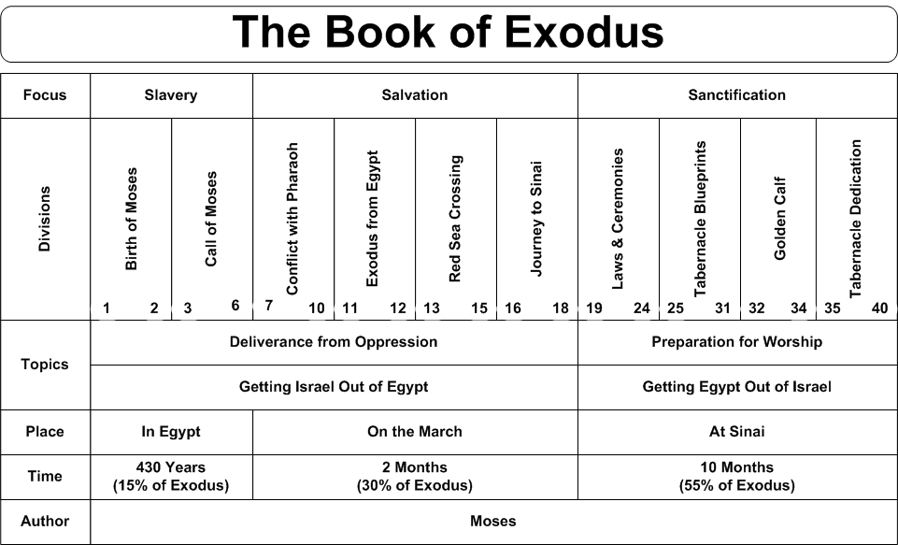
Source: http://www.swartzentrover.com/cotor/Bible/Bible/Bible%20Charts/Exodus.htm

